***Chemistry***

**7: Chemical Bonding and Molecular Structure**

**7.6: Molecular Structure and Polarity**

85. Explain why the HOH molecule is bent, whereas the HBeH molecule is linear.

Solution

The placement of the two sets of unpaired electrons in water forces the bonds to assume a tetrahedral arrangement, and the resulting HOH molecule is bent. The HBeH molecule (in which Be has only two electrons to bond with the two electrons from the hydrogens) must have the electron pairs as far from one another as possible and is therefore linear.

87. Explain the difference between electron-pair geometry and molecular structure.

Solution

Space must be provided for each pair of electrons whether they are in a bond or are present as lone pairs. Electron-pair geometry considers the placement of all electrons. Molecular structure considers only the bonding-pair geometry.

89. Explain how a molecule that contains polar bonds can be nonpolar.

Solution

As long as the polar bonds are compensated (for example. two identical atoms are found directly across the central atom from one another), the molecule can be nonpolar.

91. Predict the electron pair geometry and the molecular structure of each of the following molecules or ions:

(a) SF6

(b) PCl5

(c) BeH2

(d) 

Solution

(a) Number of valence electrons: S = 6, F = 7 each, total 48. A single line bond represents two electrons:

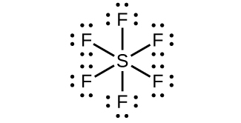.

The total number of electrons used is 48; six bonds are formed and no nonbonded pairs exist. Therefore the molecule includes six regions of electron density and, from the table, the electron geometry is octahedral. Since no lone pairs exist, the electron geometry and molecular structure are the same.

(b) Number of valence electrons: P = 5, Cl = 7 each, total 40:

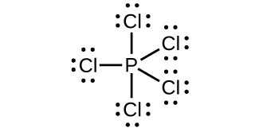.

The total number of electrons is 40; there are five regions of electron density and, from the table, the geometry is trigonal bipyramid. Since no lone pairs exist on P, the electron geometry and molecular structure are the same.

(c) Number of valence electrons: Be = 2, H = 1 each, total 4:

L:\Clients\Connexions\CONNEX130016_Chemistry\02_Working_Files\C07_Chemical Bonding and Molecular Geometry\99_Current_Art\JPEG\CNX_Chem_07_06_Exercise7c_img.jpg.

There are only two regions of electron density and they must have a linear arrangement. These regions also correspond to the location of the bonds. Both the electron and molecular structures are linear.

(d) Number of valence electrons: C = 4, H = 1 each, less one electron because of the positive charge, for a total of six electrons:

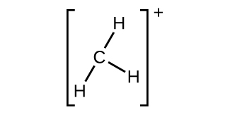.

There are three regions of electron density coincident with the three bonds. Therefore the shape is trigonal planar for both the electron geometry and molecular structure.

93. What are the electron-pair geometry and the molecular structure of each of the following molecules or ions?

(a) ClF5

(b) 

(c) 

(d) PCl3

(e) SeF4

(f) 

Solution

|  |  |  |  |  |  |
| --- | --- | --- | --- | --- | --- |
|  |  | Regions of High  Electron Density | | Structure | |
| Formula | Electrons | Total | Lone pairs | Electron | Molecular |
| (a) ClF5 | 42 | 6 | 1 | octahedral | square pyramidal |
| (b) | 20 | 4 | 2 | tetrahedral | bent |
| (c) | 36 | 6 | 2 | octahedral | square planar |
| (d) PCl3 | 26 | 4 | 1 | tetrahedral | trigonal pyramidal |
| (e) SeF4 | 34 | 5 | 1 | trigonal bipyramidal | seesaw |
| (f) | 8 | 4 | 2 | tetrahedral | bent (109°) |

95. Identify the electron pair geometry and the molecular structure of each of the following molecules:

(a) ClNO (N is the central atom)

(b) CS2

(c) Cl2CO (C is the central atom)

(d) Cl2SO (S is the central atom)

(e) SO2F2 (S is the central atom)

(f) XeO2F2 (Xe is the central atom)

(g)  (Cl is the central atom)

Solution

|  |  |  |  |  |  |
| --- | --- | --- | --- | --- | --- |
|  | | Regions of High  Electron Density | | Structure | |
| Formula | Electrons | Total | Lone pairs | Electron | Molecular |
| (a) ClNO | 18 | 3 | 1 | trigonal planar | bent (120°) |
| (b) CS2 | 16 | 2 | 0 | linear | linear |
| (c) Cl2CO | 24 | 3 | 0 | trigonal planar | trigonal planar |
| (d) Cl2SO | 26 | 4 | 1 | tetrahedral | trigonal pyramidal |
| (e) SO2F2 | 32 | 4 | 0 | tetrahedral | tetrahedral |
| (f) XeO2F2 | 34 | 5 | 1 | trigonal bipyramidal | seesaw |
| (g) | 26 | 4 | 1 | tetrahedral | trigonal pyramidal |

97. Which of the following molecules and ions contain polar bonds? Which of these molecules and ions have dipole moments?

(a) ClF5

(b) 

(c) 

(d) PCl3

(e) SeF4

(f) 

(g) XeF2

Solution

All of these molecules and ions contain polar bonds. Only ClF5, , PCl3, SeF4, and have dipole moments.

99. Which of the following molecules have dipole moments?

(a) CS2

(b) SeS2

(c) CCl2F2

(d) PCl3 (P is the central atom)

(e) ClNO (N is the central atom)

Solution

(a) CS2 is linear and has no dipole moment. (b) SeS2 is bent. This leads to an overall dipole moment. (c) The C–Cl and C–F bonds are not balanced—that is, the dipoles do not completely cancel. Therefore, it has a dipole moment. (d) PCl3 is trigonal pyramidal. Due to this shape, the dipoles of the bonds do not cancel and there is an overall dipole moment. (e) The ClNO molecule is bent, leading to a dipole moment.

101. The molecule XF3 has a dipole moment. Is X boron or phosphorus?

Solution

P

103. Is the Cl2BBCl2 molecule polar or nonpolar?

Solution

nonpolar

105. Describe the molecular structure around the indicated atom or atoms:

(a) the sulfur atom in sulfuric acid, H2SO4 [(HO)2SO2]

(b) the chlorine atom in chloric acid, HClO3 [HOClO2]

(c) the oxygen atom in hydrogen peroxide, HOOH

(d) the nitrogen atom in nitric acid, HNO3 [HONO2]

(e) the oxygen atom in the OH group in nitric acid, HNO3 [HONO2]

(f) the central oxygen atom in the ozone molecule, O3

(g) each of the carbon atoms in propyne, CH3CCH

(h) the carbon atom in Freon, CCl2F2

(i) each of the carbon atoms in allene, H2CCCH2

Solution

(a) tetrahedral; (b) trigonal pyramidal; (c) bent (109°); (d) trigonal planar; (e) bent (109°); (f) bent (109°); (g) CH3CCH tetrahedral, CH3CCH linear; (h) tetrahedral, (i) H2CCCH2 linear; H2CCCH2 trigonal planar

107. A molecule with the formula AB2, in which A and B represent different atoms, could have one of three different shapes. Sketch and name the three different shapes that this molecule might have. Give an example of a molecule or ion for each shape.

Solution

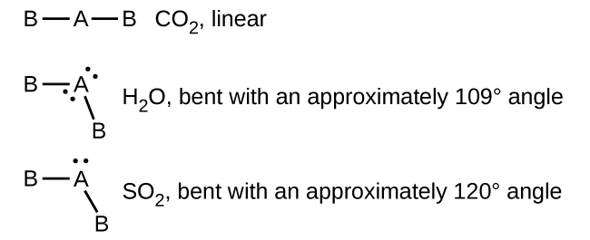

109. Draw the Lewis electron dot structures for these molecules, including resonance structures where appropriate:

(a) 

(b) CS2

(c) CS

(d) predict the molecular shapes for  and CS2 and explain how you arrived at your predictions

Solution

(a)

*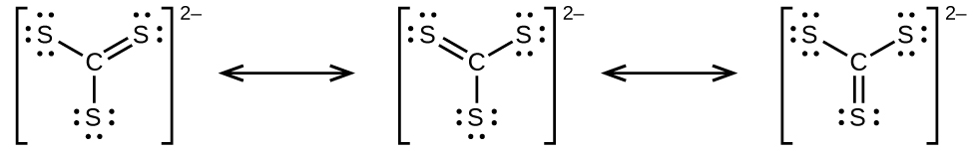*

(b)

*L:\Clients\Connexions\CONNEX130016_Chemistry\02_Working_Files\C07_Chemical Bonding and Molecular Geometry\99_Current_Art\JPEG\CNX_Chem_07_06_CS3b_img.jpg*

(c)

L:\Clients\Connexions\CONNEX130016_Chemistry\02_Working_Files\C07_Chemical Bonding and Molecular Geometry\99_Current_Art\JPEG\CNX_Chem_07_06_CS3c_img.jpg;

(d)  includes three regions of electron density (all are bonds with no lone pairs); the shape is trigonal planar; CS2 has only two regions of electron density (all bonds with no lone pairs); the shape is linear

111. A compound with a molar mass of about 42 g/mol contains 85.7% carbon and 14.3% hydrogen. What is its molecular structure?

Solution

The empirical formula is CH2 with a unit mass ofl4. . Therefore, the Lewis structure is made from three units, but the atoms must be rearranged:

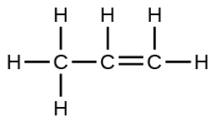

113. Use this link: http://phet.colorado.edu/en/simulation/molecule-polarity to perform the following exercises for a real molecule. You may need to rotate the molecules in three dimensions to see certain dipoles.

(a) Sketch the bond dipoles and molecular dipole (if any) for O3. Explain your observations.

(b) Look at the bond dipoles for NH3. Use these dipoles to predict whether N or H is more electronegative.

(c) Predict whether there should be a molecular dipole for NH3 and, if so, in which direction it will point. Check the molecular dipole box to test your hypothesis.

Solution

The molecular dipole points away from the hydrogen atoms.

115. Use this link: http://phet.colorado.edu/en/simulation/molecule-shapes to explore real molecules. On the Real Molecules tab, select H2O. Switch between the “real” and “model” modes. Explain the difference observed.

Solution

The structures are very similar. In the model mode, each electron group occupies the same amount of space, so the bond angle is shown as 109.5°. In the “real” mode, the lone pairs are larger, causing the hydrogens to be compressed. This leads to the smaller angle of 104.5°.

This resource file is copyright 2015, Rice University. All Rights Reserved.